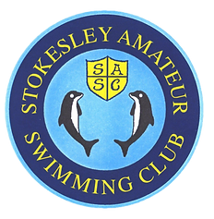
STOKESLEY ASC - AN INTRODUCTION TO COMPETITION & SWIMMING GALAS

Swimming galas are an excellent way for swimmers to see how they are progressing - it gives them goals and a reason for all those hours of training (both in and out of the water). It’s also a great gauge of their abilities against swimmers in other clubs.
Different types of Galas

INTERNAL GALAS
These are competitions restricted to members of SASC. We usually hold the following:

SASC Time Trials
These are set by the coaches at various times of the year. Swimmers from all squads tend to be involved but sometimes we focus on silver and Bronze to gauge how swimmers are progressing and to ensure they are training in the right squad, and best lane, for their increasing ability. They are also ideal events for newcomers to experience the competitive environment in a relaxed atmosphere in home waters.

Club Championships

This event is open to all swimmers in the club and is held over 2-3 weeks/weekends during October/November. This gala is purely internal (so not licensed) but is a little more competitive than the Time Trials. The format includes heats and finals of 25m and 50m races for all strokes during which the swimmers collect points. The awards from this event are presented at a Social Night, usually held in early December.

Moors League
This is a small but historic local league – and therefore very important to SASC - with 5 rounds and a final held from January to July each year.
We try to use this event to give swimmers a first experience of swimming in a team - and as individuals. Swimmers are aged 8 and above and the events are a mixture of 25 and 50 metre swims including some longer team relay events. This gala is held under Swim England rules and therefore is a little more formal than the Club Championships. It’s often the first experience swimmers have of racing in a different pool against different clubs – and it can get pretty exciting!
As all the above are classified as “Unlicensed Meets”, times achieved at these galas are not recorded on the British Swimming database.

LICENSED MEETS
All times achieved at Licensed Meets are recorded on the British Swimming Rankings database - see the link below. You will learn to love this link!! Racing age is specified by each gala and will either be “age on day” as specified by the gala organisers OR “age on 31st December.”
https://www.swimmingresults.org/individualbest
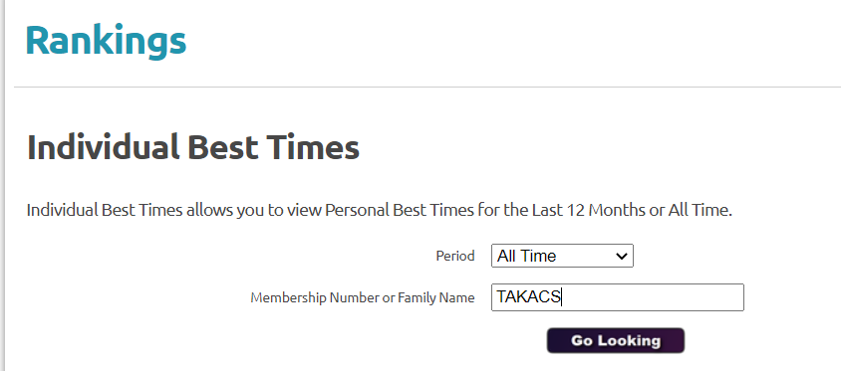
TYPE IN SWIMMERS SURNAME
Select your swimmer from the list:
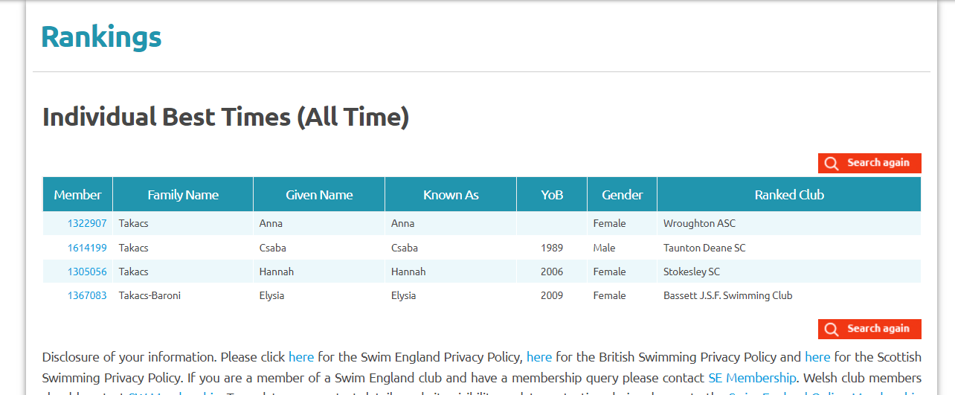
Official swimming times listed – LONG COURSE (50m) and SHORT COURSE (25m)
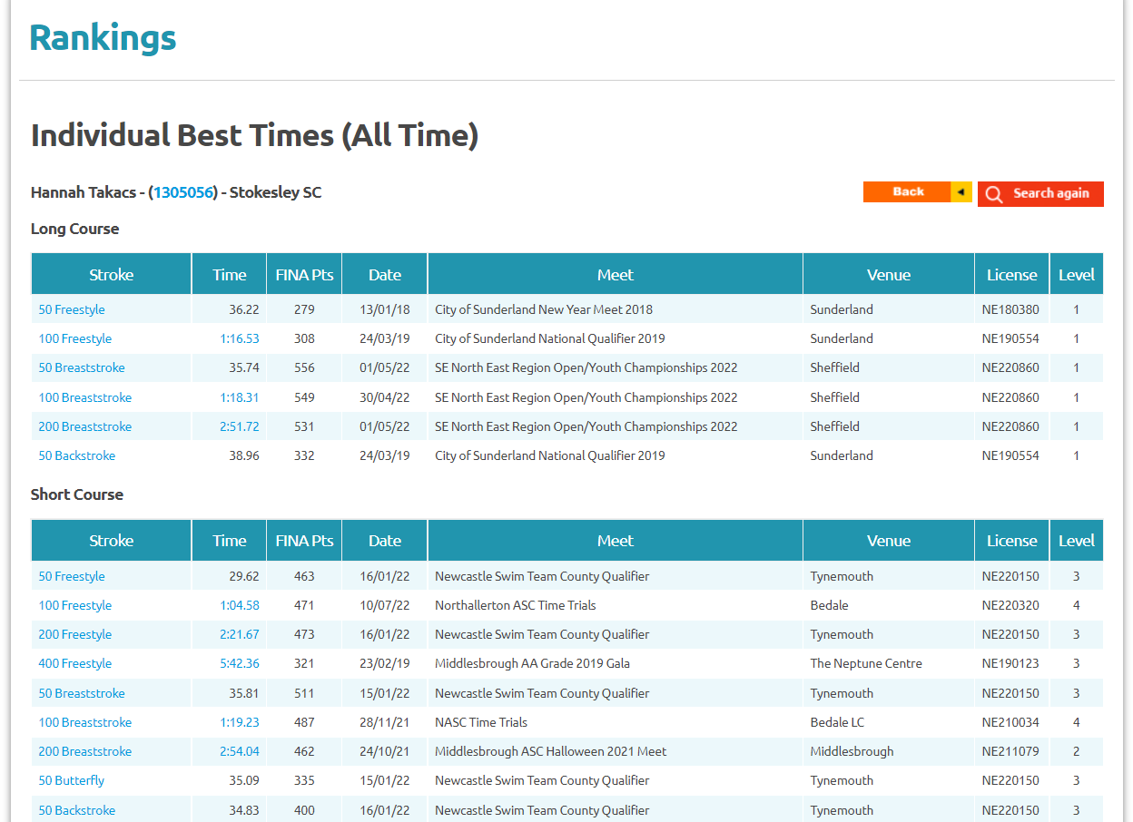

Licensed meets are competitions in which swimmers enter individually. There are different levels of Open Meets and the Coaches will always try to source the correct competition to suit your child’s development. At these meets, whilst your child is entered through the club, they are swimming for themselves. An entry fee for each race is payable and this is usually between £5 and £8. A small charge is also made towards the cost of a pass to allow the Coach on Poolside.

Level 4 Meets
This is the lowest level of Licensed Meets and there are usually no minimum entry standards. Times from these meets can be used to enter many open galas and work towards County Championships. Swimmers should be encouraged to enter a wide range of events at these galas in order to gain times on the British Swimming database which are necessary to enter other meets. Perfect example is the Bedale Time Trials run by NASC (Northallerton Amateur Swim Club).

Level 2 and 3 Meets
Level 3 usually have a maximum entry standard (cannot enter if your time is faster than xxx) which restricts the fastest swimmers from competing. Swimmers use these competitions to gain qualifying times for County & Regional competitions. These galas are nearly always in a 25m pool.

Level 1 Meets
These galas are usually held in Long Course 50m pools and are aimed at the quicker swimmers who are trying to achieve qualification for National Championships. They usually have quite fast entry standards i.e. cannot enter if your time is slower than xxxx.

County Championships – Level 2 Northumberland & Durham
SASC swimmers compete in the N & D’s Championships which are usually held in February. The qualifying standard is set to ensure that the best swimmers in the County compete against each other. The swimmer’s age will be taken as age on 31 December. Achieving a ‘County Time’ is a major milestone on your child’s swimming journey.

Regional Championships – Level 1
We compete in the North East Region and the galas usually take place in May & November. They are nearly always held in a Long Course pool (50m pool) and the qualifying times are quite tough to achieve. As at the County Championships, the age will be as at 31 December.

National Championships
These championships are held in July and August in a Long Course pool (usually Ponds Forge, Sheffield). To qualify, swims recorded at Level 1 meets during the qualification window are ranked for each age group and the top 24 for each event will be invited to swim at British National Age Group Championships. The next 20 swimmers from each home nation are invited to swim at the Home Nations National Championships. The age is at 31 December.
You may like to record information about the dates, venues, distances, strokes and times achieved by your swimmer. Not only is it useful when it comes to completing entry forms, but it is also a great way of monitoring progress. We maintain the club’s PB sheet - which we publish onto the website as well as display a hard copy on our board at the Leisure Centre. However, we do include PB times recorded at the Moors League galas or our own time trials and unfortunately these are not recorded on the British Swimming Rankings database.
SASC PROCESS FOR ENTERING GALAS
The committee and coaches will aim to publish a calendar every 6 months or so of galas we would propose to attend. The galas will be chosen for their suitability for all levels of swimmers - including those who are competing for the first time to those who would like to gradually progress on a pathway from level 4 to County level.
No Galas are compulsory – it is completely up to the parents and swimmers if they want to enter a competition.
We do however insist that swimmers take part in internal SASC time trials and also stress the importance of prioritising the Moors League Galas if your swimmer is selected for the team. The Moors League calendar is usually issued sometime early December for the following year.
We will send out information about a particular event as soon as we receive the details from the organisers. Hard copies will also be pinned on the board at the Leisure Centre. These documents will have a closing date set by the organisers but these will NOT be the closing date we set internally. Our Entries Secretary needs time to collate entries, check times etc and complete the electronic entry system so we will set and clearly state our internal club deadlines for each gala.
We will ask you to email your selection of races for each swimmer to the SASC Gmail address before the internal deadline. If you have any queries on which events to enter, please speak to the coaches who will advise accordingly. We will then collate all entries and send a summary sheet with entry fees owed to our SASC parents/ swimmers.
Please do not send your list of events directly to the organisers. Details of accepted entries, arrival times, spectator information etc are then sent out by us to parents nearer the date of the competition.
Any queries or if you’d like more information, please do not hesitate to contact any of the coaches or committee either in person or via email.
stokesleyasc@gmail.com

SASC Gala Info 08/08/22

